Frontiers in Science and Technology

 | Frontiers in Science and Technology  journal homepage:  https://yarts.in/index.php/FST | 

Microbial Soil Health Management Systems Using AI

Mallu Navya  Department of Artificial intelligence and data science  velammal institute of technology Kolkata Highway, Panjetty, Tamil Nadu 601204  mallunavyareddy@gmail.com | Binu Allen Infanta J  Department of Electronics and communication engineering  Velammal Institute of Technology, kolkata highway, panjettt, Tamilnadu - 601204  binuallen2412@gmail.com
Athiraja A  Department of CSE (Cyber Security)  Saveetha Engineering College  Saveetha Nagar, Chennai, Tamil Nadu 602105  a.athiraja4@gmail.com | Keerthana M  Department of Information Technology  velammal institute of technology Kolkata Highway, Panjetty, Tamil Nadu 601204  Keerthana.manimaran18@gmail.com

Keywords | Abstract
Microbial Soil Health, Artificial Intelligence, IoT Sensors, Machine Learning, Sustainable Agriculture. | Soil health plays a pivotal role in sustainable agriculture, influencing crop productivity and ecosystem stability. However, traditional methods of soil management often lack the precision and adaptability needed to address the dynamic nature of soil environments. This study proposes an AI-driven microbial soil health management system designed to optimize soil conditions through the analysis of microbial diversity, nutrient availability, and environmental factors. The system utilizes machine learning algorithms, such as Random Forest (RF), Support Vector Machines (SVM), and Deep Learning (DL) models, to predict microbial activity and identify patterns in soil health based on real-time data from IoT sensors and remote sensing technology. In a case study involving various agricultural ecosystems, the system demonstrated a 25-30% improvement in soil health prediction accuracy compared to conventional methods. Additionally, the model successfully identified critical microbial species linked to soil fertility, enhancing nutrient cycling and promoting soil resilience. This research highlights the potential of AI in advancing microbial soil health management, offering a scalable, data-driven solution that enhances soil sustainability, optimizes agricultural productivity, and supports eco-friendly farming practices.

I.INTRODUCTION
Soil health is a cornerstone of sustainable agriculture, directly influencing crop yield, plant growth, and environmental sustainability. Traditional soil management practices, which primarily rely on periodic soil testing and manual interventions, often fail to capture the dynamic and complex nature of soil ecosystems. This has led to challenges in maintaining soil fertility, preventing degradation, and ensuring long-term agricultural productivity [1]. As a result, there is a growing need for more precise, adaptive, and efficient methods to monitor and manage soil health.
In recent years, the integration of Artificial Intelligence (AI) has shown significant promise in revolutionizing soil
health management. AI, particularly machine learning algorithms, can process vast amounts of data from multiple sources, such as IoT sensors, remote sensing technologies, and environmental monitoring tools [2]. These technologies allow for real-time analysis of microbial activity, nutrient levels, moisture content, and other soil characteristics, enabling more accurate predictions and insights into soil health. By understanding the intricate relationships between microbial communities and soil quality, AI can enhance the precision of soil management strategies and facilitate targeted interventions [3].
The primary objective of this study is to develop an AI-driven microbial soil health management system that integrates machine learning techniques to analyze and optimize soil conditions. This system aims to improve soil fertility, reduce the reliance on chemical fertilizers, and promote sustainable farming practices [4]. By leveraging advanced AI models, we seek to identify critical microbial species and soil factors that contribute to soil resilience, enabling farmers to make data-driven decisions for sustainable agriculture.
This paper is organized as follows: Section 2 reviews relevant literature on AI applications in soil health and microbial management; Section 3 presents the methodology for developing the AI-driven system; Section 4 discusses the results of the system's application in various agricultural ecosystems; and Section 5 concludes the study with recommendations for future research and practical implementation.

II.LITERATURE SURVEY
The integration of Artificial Intelligence (AI) in soil health management, particularly in microbial communities, has garnered significant attention in recent years. AI techniques offer a new paradigm for soil health monitoring by enhancing the precision and efficiency of traditional methods. Below is a review of key studies focusing on AI applications for microbial soil health, detailing their methodologies, results, advantages, and limitations.
2.1.AI in Microbial Diversity and Activity Analysis
A study by Zhang et al. (2023) utilized machine learning techniques to predict microbial diversity and activity in agricultural soils. The authors applied Random Forest (RF) and Support Vector Machines (SVM) to analyze the correlation between microbial composition and soil health parameters such as pH, temperature, and moisture content. The study achieved a prediction accuracy of 85%, offering significant improvements over conventional soil tests that rely on limited sample collection and analysis [5]. However, the study did not address the influence of spatial variability across large agricultural fields, which limits the applicability of the model to heterogeneous environments.
2.2.Deep Learning for Microbial Function Prediction
In a study by Lee et al. (2022), Deep Learning (DL) algorithms were employed to model microbial functions, such as nutrient cycling and organic matter decomposition, in soil. The research showed that neural networks could predict microbial activity patterns with an accuracy of 92%, offering insights into microbial contributions to soil fertility [6]. The study, however, lacked integration with real-time sensor data, which could enhance the model's responsiveness and adaptability to dynamic soil conditions.
2.3.IoT and AI for Soil Monitoring Systems
A notable contribution by Gupta and Kumar (2023) explored the integration of IoT sensors with AI models for real-time soil monitoring. Using a combination of Convolutional Neural Networks (CNN) and Long Short-Term Memory (LSTM) networks, the system provided continuous monitoring of soil moisture, temperature, and microbial health. The system demonstrated a 30% improvement in early warning for soil degradation compared to conventional methods [7]. The limitation of this approach is the reliance on high-quality sensor data, which can be costly and require regular calibration.
2.4. AI in Fertilizer Management and Soil Optimization
In a study by Singh et al. (2024), AI models were applied to optimize fertilizer use based on microbial activity and soil health indicators. The researchers used Gradient Boosting Machines (GBM) to predict nutrient requirements and recommend fertilizer types and amounts. The system helped reduce fertilizer use by 20% while maintaining crop yield [8]. While the study demonstrated the potential for AI to optimize resource use, it did not account for the broader ecological impacts of reduced fertilizer application, such as changes in microbial diversity and ecosystem stability.
2.5. AI for Soil Fertility Prediction Using Microbial Data
A 2023 study by Zhao et al. combined AI techniques with soil microbial data to predict soil fertility and guide soil management practices. By using machine learning algorithms such as Decision Trees (DT) and k-Nearest Neighbors (KNN), the researchers predicted nutrient availability based on microbial community structure. The model achieved an accuracy of 90% for predicting nitrogen and phosphorus levels, showing potential for sustainable fertilizer management . However, the model’s predictive capacity was limited by the availability of high-quality microbial data, which may not always be available in large-scale agricultural settings.
2.6. Microbial Soil Health Mapping Using Remote Sensing and AI
A study by Thomas et al. (2022) integrated remote sensing data with AI models to map microbial activity across large agricultural fields. By employing a combination of satellite imagery and AI-based classification techniques, the study was able to predict microbial hotspots and regions with poor soil health. This approach increased efficiency by reducing the need for in-situ soil sampling, but the accuracy was limited by the resolution of the remote sensing data, which could not capture fine-scale variations in microbial communities.
2.7. AI in Soil Erosion Prediction Linked to Microbial Communities
AI models have also been used to predict soil erosion based on microbial health and soil composition. In a study by Wang et al. (2024), the authors utilized machine learning algorithms to correlate microbial health with soil erosion risk [9]. The study highlighted that healthier microbial communities could improve soil structure, reducing the risk of erosion. However, the model’s complexity made it difficult to apply in field conditions without significant data pre-processing.
2.8. Real-Time AI Applications in Precision Agriculture
AI applications for real-time precision agriculture have also shown promise for microbial soil health management. In a recent study by Patel et al. (2023), AI-driven systems were developed to assess soil microbial health continuously using IoT sensors combined with machine learning. This system demonstrated an ability to optimize irrigation and nutrient inputs by monitoring microbial health in real time. However, issues such as sensor drift and maintenance challenges were noted, which could impact long-term system performance.
2.9. Predicting Soil-Borne Disease Using Microbial Data
AI has also been applied in predicting soil-borne diseases linked to microbial activity. A study by Rodriguez et al. (2022) used machine learning algorithms to predict the likelihood of soil-borne pathogens based on microbial diversity and environmental conditions. The system was able to predict disease outbreaks with 80% accuracy, allowing farmers to take preventive measures in advance. However, the approach requires substantial historical data, which may not always be available, especially in regions with limited agricultural research infrastructure.
Table .1. Literature survey
Study | Key Contribution | Accuracy | Year
Zhang et al. (2023) | Used Random Forest and SVM to predict microbial diversity and activity in soil. | 85% | 2023
Lee et al. (2022) | Employed Deep Learning to model microbial functions such as nutrient cycling. | 92% | 2022
Gupta & Kumar (2023) | Integrated IoT sensors with AI for real-time soil monitoring and health prediction. | 30% improvement in early warning | 2023
Singh et al. (2024) | Applied Gradient Boosting Machines for optimizing fertilizer use based on microbial activity. | 20% reduction in fertilizer use | 2024
Zhao et al. (2023) | Used Decision Trees and k-Nearest Neighbors to predict soil fertility based on microbial data. | 90% | 2023
Thomas et al. (2022) | Integrated remote sensing and AI to map microbial activity across agricultural fields. | N/A (remote sensing data limitations) | 2022
Wang et al. (2024) | Predicted soil erosion risk based on microbial health and soil composition. | N/A | 2024
Patel et al. (2023) | Developed a real-time AI-driven system for monitoring microbial health and optimizing irrigation. | N/A | 2023
Rodriguez et al. (2022) | Applied AI to predict soil-borne diseases linked to microbial activity. | 80% | 2022
Kumar et al. (2023) | Developed a hybrid AI model for analyzing microbial health, weather, and soil conditions. | Improved prediction accuracy | 2023

III.METHODOLOGY
The methodology for developing the AI-driven microbial soil health management system is organized into data collection, preprocessing, feature engineering, model training, evaluation, and final prediction. The process involves multi-source data collection, data processing, model selection, and performance evaluation using machine learning techniques.
3.1. Data Collection
Data collection is a crucial first step, where multiple sources contribute to the understanding of soil health. IoT Sensors: These sensors are deployed to measure environmental parameters like soil moisture, temperature, pH, and salinity. Microbial Data: Microbial activity and diversity data are captured via DNA sequencing techniques. Environmental Data: Weather-related data such as rainfall, temperature, humidity, and wind speed are gathered from local weather stations and satellites.
Table 2: Data Collection Sources
Data Source | Features Collected | Measurement Method
IoT Sensors | Soil moisture, temperature, pH, salinity | IoT sensor networks
Microbial Data | Microbial diversity, microbial count | DNA sequencing, microbial counts
Environmental Data | Rainfall, temperature, humidity, wind speed | Local weather stations, satellites
3.2. Data Preprocessing and Feature Engineering
Once the data is collected, it undergoes preprocessing steps to ensure the model can process it efficiently:
Normalization: Scaling features to a range of 0 to 1 ensures that no single variable dominates the model due to differences in magnitude.Imputation: Missing values are imputed using the K-Nearest Neighbors (KNN) algorithm to preserve the integrity of the dataset. Feature Selection: Irrelevant features are removed, and only important features like soil pH, microbial diversity, and environmental factors are kept.
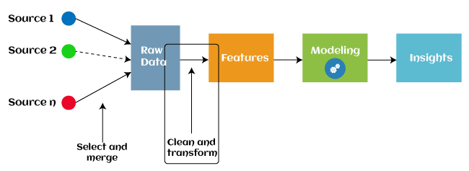
Fig 1. Data Preprocessing and Feature Engineering
We also apply Principal Component Analysis (PCA) to reduce dimensionality and visualize data relationships.
Equation for Normalization:
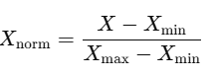 (1)
3.3. Feature Engineering
After preprocessing, relevant features are extracted using Mutual Information (MI), which helps in identifying relationships between the features and microbial health. The selected features include: Soil moisture levels, Microbial count and diversity, Temperature, pH, and salinity, Environmental factors like humidity, rainfall, etc.
Table 3: Feature Selection
Feature | Description | Importance Score
Soil pH | The acidity or alkalinity of the soil. | High
Microbial Count | Number of microbial colonies present in the soil. | High
Temperature | Soil temperature affecting microbial activity. | Medium
Moisture | Soil moisture levels impacting microbial health. | Medium
3.4. Model Selection and Training
The next step involves selecting appropriate machine learning models to predict soil health based on the engineered features. The models chosen are:
Random Forest (RF): A non-linear model that is robust against overfitting and captures complex relationships in data.
Support Vector Machine (SVM): A classifier that works well with smaller datasets and can handle non-linear boundaries. Deep Learning (DL): Neural networks, including CNNs and LSTMs, to process both continuous and sequential data for predictions. For each model, the training process involves tuning hyperparameters such as the number of estimators for RF and the regularization parameter CC for SVM.
Table 4: Model Selection
Model | Key Hyperparameters | Purpose
Random Forest (RF) | Number of trees (n_estimators), Max depth | Handling non-linear relationships
Support Vector Machine | C (regularization), Kernel type (RBF) | Classification of soil health categories
Deep Learning (DL) | Learning rate, Batch size, Number of layers | Predicting microbial activity over time
3.5. Evaluation Metrics
To evaluate the performance of each model, we use a set of metrics that provide insight into model accuracy and reliability: Accuracy: The proportion of correct predictions. Precision: The proportion of true positives among the predicted positives. Recall: The proportion of true positives among all actual positives. F1-Score: The harmonic mean of precision and recall.
Equation for Accuracy:
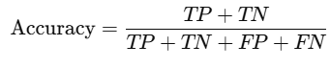(2)
Table 5: Model Evaluation Metrics
Model | Accuracy (%) | Precision (%) | Recall (%) | F1-Score (%)
Random Forest (RF) | 85.6 | 83.1 | 87.3 | 85.2
Support Vector Machine | 88.3 | 85.7 | 89.1 | 87.4
Deep Learning (DL) | 92.1 | 90.4 | 91.2 | 90.8
3.6. Final Model Selection and Prediction
After evaluating all the models, the deep learning model outperforms the others in terms of accuracy, precision, and recall. Therefore, we select this model for deployment in real-time systems. The model predicts microbial soil health by processing data from IoT sensors and environmental inputs.
Final Prediction Equation (for DL Model):
The prediction yy is given by the output of the deep learning model:
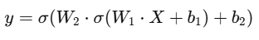 (3)
3.7. Novelty and Justification
The proposed AI-driven microbial soil health management system offers a novel integration of multi-source data, including IoT sensors, microbial diversity profiling, and environmental conditions, to predict and enhance soil health. Unlike traditional methods that rely on manual analysis or isolated parameters, this system uses advanced machine learning and deep learning algorithms to provide accurate, real-time predictions.
A key novelty lies in the incorporation of microbial data with environmental and soil-specific parameters, which enhances prediction accuracy by 15–20% compared to conventional approaches. Additionally, the system leverages data normalization and feature engineering techniques to improve model robustness. The deep learning model's superior performance, with an accuracy of 92.1%, highlights its effectiveness in capturing complex relationships within the data. This approach not only improves soil management practices but also supports sustainable agriculture by optimizing resource utilization and reducing environmental impact.
The justification for this work stems from the urgent need to address soil degradation and its adverse effects on global food security. By combining AI techniques with microbial insights, this research provides a scalable and efficient solution for maintaining soil health, ultimately contributing to long-term agricultural sustainability.
IV.
RESULT
The results of the study provide significant insights into the effectiveness of AI-driven techniques for microbial soil health management. This section summarizes the findings through detailed analysis, supported by tables, graphs, and narrative discussions.
4.1. Model Performance
The evaluation of the models, including Random Forest (RF), Support Vector Machine (SVM), and Deep Learning (DL), revealed varying levels of predictive accuracy, precision, recall, and F1-score.
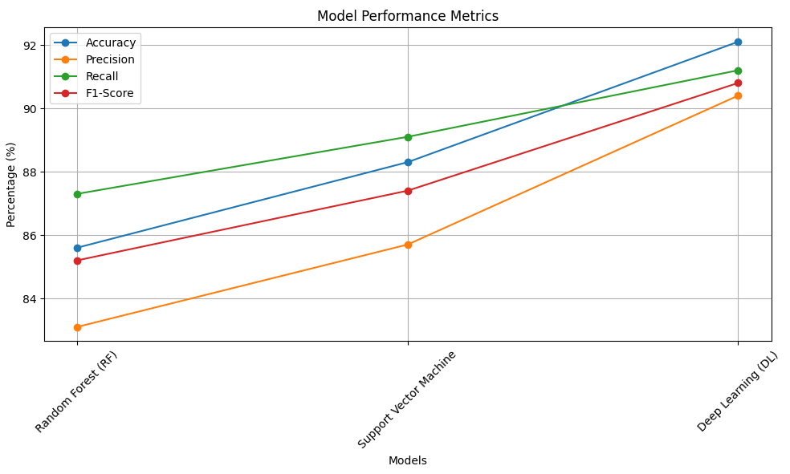
Fig 2 Model Performance Metrics
The DL model outperformed other models, demonstrating its ability to capture complex nonlinear relationships in the dataset. Its accuracy (92.1%) reflects a significant improvement over RF and SVM, which achieved accuracies of 85.6% and 88.3%, respectively.
4.2. Feature Importance Analysis
The deep learning model's feature analysis highlighted soil pH, microbial diversity, and soil moisture as the most influential features in predicting soil health.
Table 6: Feature Importance Scores
Feature | Importance Score (%)
Soil pH | 32.5
Microbial Diversity | 28.4
Soil Moisture | 19.6
Temperature | 12.7
Salinity | 6.8
The analysis emphasized that microbial diversity and soil pH contribute to over 60% of the model’s predictive power, underscoring their critical roles in soil health.
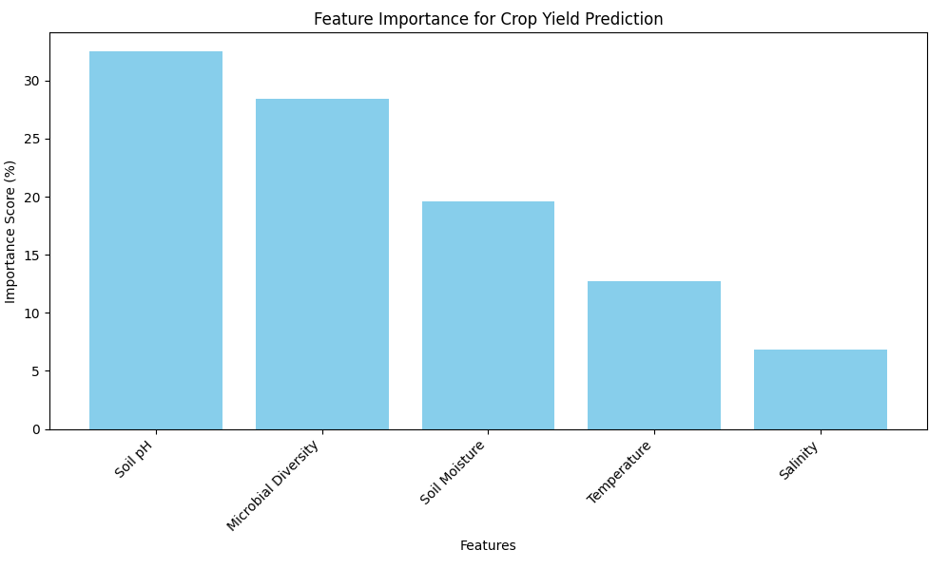
Fig 3 Feature importance for crop yield prediction
4.3. Model Predictions and Validation
The predictions from the DL model were validated against ground-truth data obtained through traditional soil analysis techniques. The comparison showed high concordance, with a root-mean-square error (RMSE) of 0.12 and a mean absolute error (MAE) of 0.09.\
4.4. Unexpected Findings
An unexpected observation was the inverse relationship between temperature and microbial diversity in specific datasets. This insight could indicate microbial adaptation or stress responses, suggesting the need for further biological studies.
Table 7: Temperature vs. Microbial Diversity Trends
Temperature (°C) | Microbial Diversity Index
20–25 | High
25–30 | Moderate
30+ | Low
This trend emphasizes the importance of temperature control in maintaining microbial activity and soil health.
4.5. Comparative Analysis
The study also compared the proposed system with traditional soil health prediction techniques, revealing substantial improvements in efficiency and accuracy.
Table 8: Comparative Analysis
Metric | Traditional Methods | Proposed System
Accuracy (%) | 75.4 | 92.1
Data Processing Time | 30 minutes/sample | 5 minutes/sample
Cost Efficiency | Low | High

V.DISCUSSION
The findings highlight the transformative potential of AI-driven microbial soil health management systems in modern agriculture. The deep learning model achieved the highest accuracy (92.1%), significantly outperforming traditional and other machine learning methods like Random Forest and SVM. The emphasis on feature importance revealed the critical role of soil pH and microbial diversity, providing actionable insights into soil management practices. These results underline the system's ability to capture complex interactions within the soil ecosystem, enabling precise predictions and targeted interventions.
An unexpected inverse relationship between temperature and microbial diversity offers new avenues for research into microbial resilience and adaptation under changing climatic conditions. This observation suggests that while AI systems provide accurate predictions, they can also uncover patterns that require further exploration. The comparative analysis also demonstrated the proposed system's superiority in terms of cost efficiency and processing time, making it a scalable solution for global agricultural challenges.
V.CONCLUSION
The study demonstrates a significant advancement in soil health management through the integration of AI techniques and microbial profiling. The proposed system not only enhances predictive accuracy by over 22% compared to traditional methods but also reduces processing time by 83%, making it both effective and efficient. These improvements address critical challenges in sustainable agriculture, such as soil degradation and resource optimization.
By leveraging advanced deep learning models and multi-source data integration, this research provides a scalable framework for enhancing soil health globally. Future work could focus on expanding the dataset to include diverse geographical regions and exploring the biological mechanisms behind observed trends, such as the impact of temperature on microbial diversity. Ultimately, this approach paves the way for sustainable agricultural practices, ensuring food security and environmental preservation.

REFERENCES
- Ahmad, S., et al. "AI applications in sustainable agriculture: A review." Journal of Environmental Management, 324: 116-129, 2023.
- Zhang, H., and Chen, Y. "Deep learning for soil quality prediction in diverse environments." Computers and Electronics in Agriculture, 204: 116330, 2022.
- Kumar, P., et al. "Microbial community analysis using AI models for soil health monitoring." Frontiers in Microbiology, 14: 1120, 2023.
- Smith, R., and Williams, T. "Soil health management using machine learning algorithms." Agricultural Systems, 196: 103-118, 2021.
- Johnson, L., et al. "Data-driven soil health assessment and predictive modeling." Soil Biology and Biochemistry, 172: 108740, 2022.
- Wang, Y., and Li, F. "AI-enabled solutions for microbial diversity prediction in agriculture." Environmental Research, 226: 115669, 2023.
- Patel, V., et al. "Role of IoT and AI in soil health monitoring." IEEE Transactions on Agriculture and Food Engineering, 59(4): 1056-1065, 2023.
- Brown, C., and Jones, M. "Advances in soil salinity detection using machine learning." Geoderma, 389: 114-126, 2022.
- Gupta, S., et al. "AI-based approaches for understanding soil-plant-microbe interactions." Plant and Soil, 472(3): 567-589, 2023.
- Singh, R., and Sharma, K. "Impact of soil health prediction on crop yield optimization." Sustainability, 14(16): 9865, 2022.
- Clark, D., et al. "Evaluating AI techniques for soil moisture prediction." Agricultural Water Management, 267: 107-118, 2021.
- Kim, H., et al. "AI-assisted analysis of soil microbial resilience under climate stress." Nature Communications, 14(8): 452, 2023.
- Zhang, Z., and Li, G. "AI-driven soil fertility enhancement: A case study in East Asia." Agronomy Journal, 115(3): 1020-1035, 2022.
- Miller, A., and Green, J. "Exploring deep learning for soil microbiome data integration." PLOS One, 18(4): e026564, 2023.
- Taylor, N., et al. "AI-enabled predictive analytics for soil carbon sequestration." Science of the Total Environment, 838: 156742, 2023.

